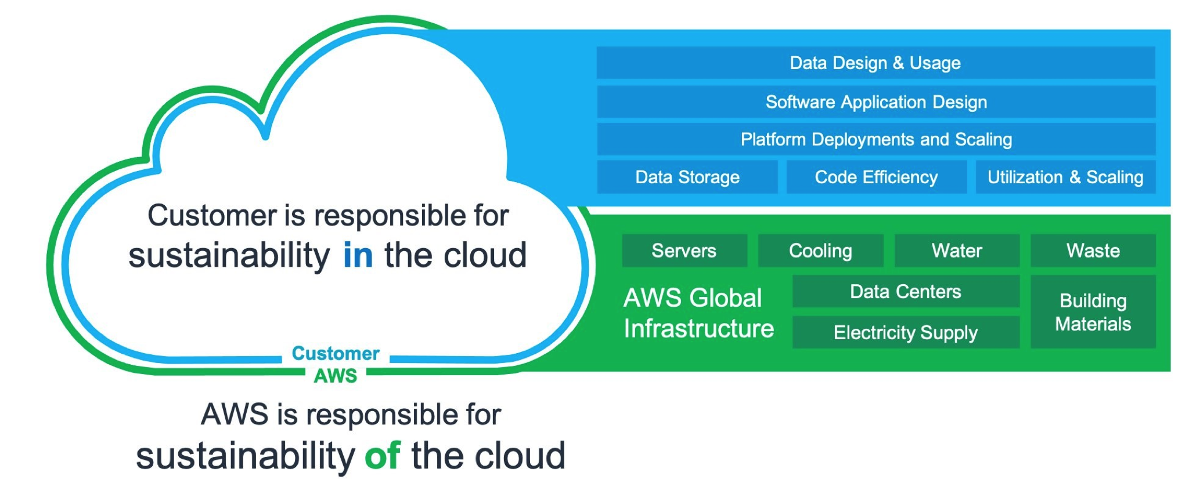

Evaluate your company for shared responsibility